**CSSE1001: 2019 S1 Exam**

[**UQAttic**](http://uqattic.net)

[**Other exam papers**](https://drive.google.com/open?id=0B_gnBD5zp3rqT2hrLWhvd2Rkc1U)

Please **contribute** to these documents.

If you're looking for an effective way to familiarise yourself with the course material, you can't go past collaborating with fellow students. We have laboured to put these up, and so at the very least point out where you think we are wrong!

You'll get more out of the course, you'll do better in the exam, and other students will benefit from your input as well.

To get editing permissions, visit [UQAttic.net](http://uqattic.net) and provide us with your Google Account address.

**Style.**

Type answers in blue beneath each question.

If you're unsure of your answer, highlight your answer text then hit Ctrl+Alt+M to create a comment beside the text. Once you're satisfied with the answer, click the "Resolve" button on the comment.

If you want some extra explanation from someone else on their answer, highlight the other person's answer and repeat the procedure above.

Feel free to contribute, ask questions and provide explanations and proofs.

If you have doubts about the answers, please **discuss** first before directly modifying them.

1. C

2. A

3. B

4. C

5. E (b and d)

6. B - Why not A as in question 8? Thanks That behaviour only occurs when working with lists, even though the string was assigned to a new variable and then that variable changed, that does not change the original string

7. B

8. A

9. D

10. C

11. C - Why not C?[+2], i think it is C, isn’t it? Checked in Python, it should be C.

12. A - I am pretty sure the answer is A, since inside the function there is no “global a”, so “a” is just a local variable. [+5] Confirmed to be A by Peter O’Shea in lecture on 23/10/19 So what does “global variable a” refer to in the question? The “global variable a” refers to “a = 9”, as that you can still access “a” inside functions. But since in this question, function f() simply declared “a” as a local variable, so it had nothing to do with the “global variable a”. See this picture for clarity

The ans should be C, check in idle. [+1]

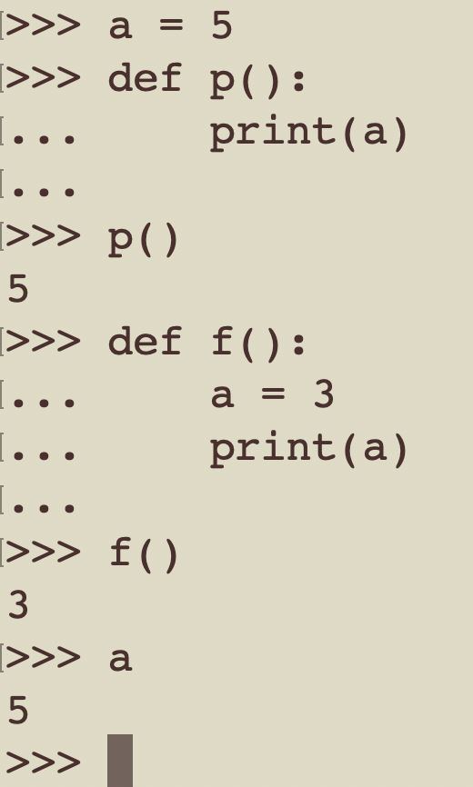

Should be D: 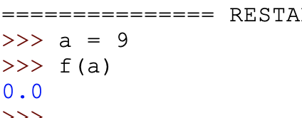

13. B - <- someone accidentally deleted number 13 so everything after this had the wrong number label FYI

14. C - Nothing means there are NO OUTPUT, new line means the output is “\n”. print() has a default of “end=’\n’”, a print() function call will print out a new line. But since there are no print() function calls, there are no output.

If you’d have a return statement would there still be no output? As long as there are no print() function calls, yes.THANK YOU Yes, it makes sense. Print will cause a new line in the python shell or Spyder monitor, but since you cannot see any output generated by this code, C is the correct answer. [+1]

There’s no output because initially it says X = 0, whereas the function will run if X > 0. Since we don’t have any other values for X, nothing will be printed., so no output. Try to put it in the idle and change X = 5 you will see 5 lines of stars. [+1]

15. A - the question uses elif statements, so once the criteria fits it doesn’t go through everything else, so I think its A [+5]

16. C - I ran it through code and its ‘no change’, 30 in the list doesn’t add to the tally Pretty sure it The answer is A since you can’t assign values to function calls. “float(variable) = value” will produce a syntax error. Sorry, I'm a little confused by this, didn’t we do something similar with using like variable = float(input(“enter a number”)), because it reads the docco as a massive string so you’d need to convert it to a number to actually perform calcs?

The case you gave is necessary, yes. But option C was “float(max_wind_speed)= float(wind_speed)” Which is wrong in this case. You can put float() around the value, but you can’t put float() around the variable you’re trying to assign to.Ohhhh, okay, since it’s on both sides its having an issue, gotcha, cheers

Also note that by selecting D and C for 25 and 26 respectively, you’ve already converted the max_wind_speed and the wind_speed to floats

For answer A, are they just strings? If they are strings, can you simply compare them just like you compare integers? Is “9” not greater than “11”?

Can someone explain this one pls??? COLDER VALUE =3 AND HOTTER VALUE = 3 - COLDER = HOTTER → ELSE : PRINT NO CHANGE - C Thanks!

17. C - You’ve already changed them to floats in the previous parts was C before, cheers………..

18. C - shouldn’t it be C?(+1) According to tutor Steven Summers the answer is C - no caching is performed to improve lookup times because Python doesn’t have a concept of constants

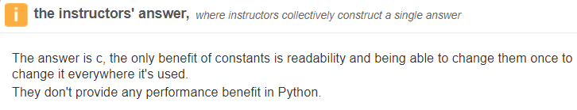

19. D

20. C

21. A - for i in options:

print ("{})".format(i), options.get(i))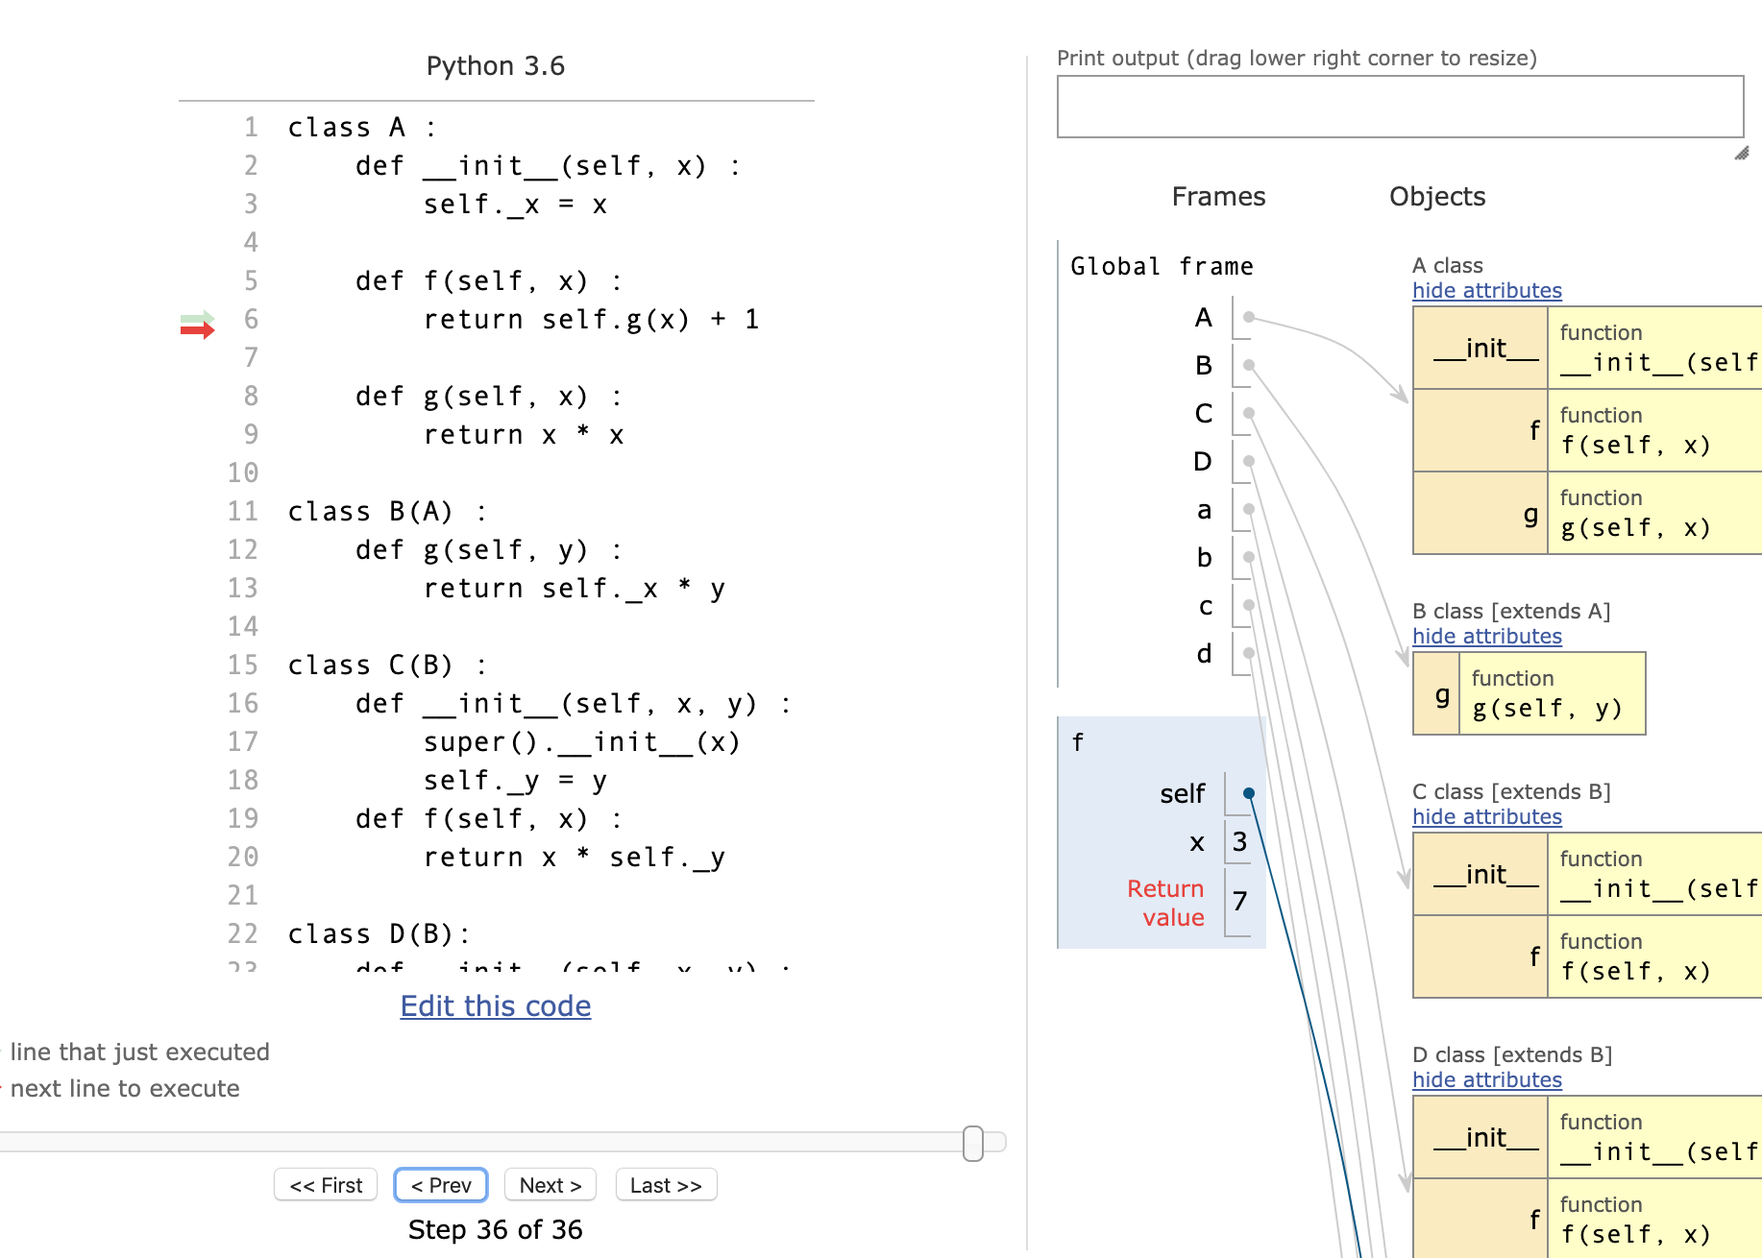

22. E

23. C - Explanation? This function was hella confusing but basically it takes the output from the number before the one you entered, and adds the number you entered to this. I know it doesn't make sense but just do r(0) and keep adding 1 until you get to 5, you'll get it. USE PYTHON VISUALIZER <http://www.pythontutor.com/visualize.html#mode=display>

24. A

25. D - What’s up with the [0]?. Setting the first value at index[0] to initial max other values are compared to it later Why do you bother converting to float when python has weak typing? Couldn’t the answer be B No operations are performed that would convert an all-integer sequence into floats, say in the case where the wind speed is recorded as 10,10,10,10. The output is a float, so to be safe it’s best to convert

26. C - Same issue as 25 couldn’t the answer be D? Same as above

27. A - why?

28. B - Why not D? Dicts don’t have a method set try: dir(dict)

29. D - WHY NOT B? The “grade” in B is referring to the key in the dictionary, which is “course”.

30. C

31. C - Answer by tutor Steven Summers on Piazza: personally I don't like any of them so I'd maybe go with (e) but If it's not (e) then (d) would be my next choice. Tutors said it was (a) in recent revision   
  
USE Use python visualiser for class

32. C

33. A - answer is 7 - I also think it is 7(a)

***Is it sure to be 7 ? i get 7 when I run the code***

(Q33 was originally A)

34. C - explanation please? In class B, is self._x 2 or 4? (inherit from class A, or take from b = B(2))?

35. B - can someone explain this? Class D inherits from B, not C, so it uses Class B’s f() function.

Why does it inherit from B and not C? Oh, it’s in the brackets. Thank you.

36. D - Isnt this D? B has no self. before the methods in command

E - I think it must be E since command can be either self. or no need self. When I tried it in Python, it didn’t work without self., so it should be D only. 36 was originally D, but it was changed by someone. Please DO NOT directly edit the black answers.

37. B - Is there not padding in the displayed tk app? Shouldn't it be B? Yup must be B

38. C - Are time complexity questions even going to be in the exam?

39. A - Doubt this is O(1), but I’m unsure. The time to execute “is_leap_year(400)” is definitely shorter than “is_leap_year(401)”.

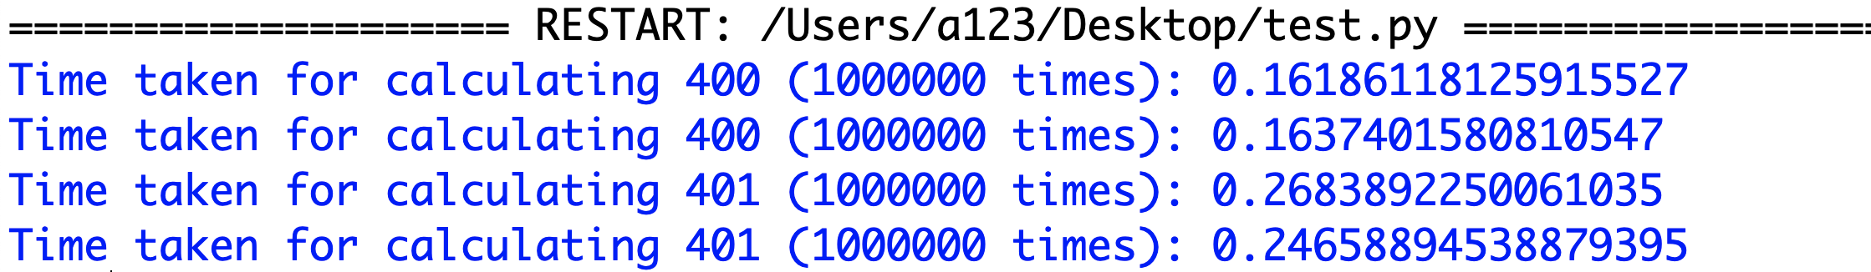

I ran the function for the cases 400 and 401 one million times twice (for consistency). It is definitely not O(1).

Especially it takes longer to calculate “year % 400” if “year” is some big value. I’m guessing it’s O(N).

I believe it is constant because the function just does predefined arithmetic and is not iterating over anything e.g. 2000 would not take any longer than 400 as it is just performing the same checks.

The reason those two differ in time is that because 400 makes the first if statement true and straight away returns true, where as 401 has to perform all three checks before returning false hence the time difference.

40. B